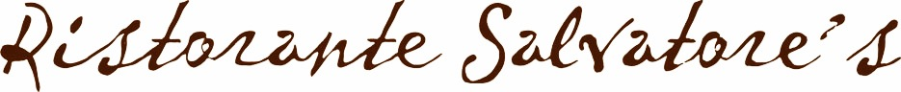

Salvatore’s is a local family-run Italian restaurant in Penwortham, Preston.

The Pizza/Pasta Offer

Any Pizza or Pasta with a pint of Peroni or 175ml glass of house wine £9.95
*soft drinks also available

Expires 31st March 2015
**************
The Table D’hôte offer

Monday – Sunday
2 course meals from £10.95

Contact the restaurant for terms and conditions
**************
The Premium Offer

Any starter from the a la Carte menu with an 8oz fillet steak
and glass of prosecco
£38.95 per couple

Excludes Valentines Day / Expires 31st March 2015
**************

To take advantage of ‘The Premium Offer’ and ‘The Pizza/Pasta Offer’, please print this page and show it to a member of staff when visiting Salvatore’s

61-63 Liverpool Road, Penwortham, Preston, PR1 9XD / 01772 746602

Find us on Facebook at Salvatore's Ristorante: Penwortham or visit www.salvatorespreston.co.uk

